Computer Networks - Assignment-II
Name: Bashair Yaqoob Roll No: 24K-0810
Task 1
1. Why reliable transfer?
The packets carry casualty lists, supply requests and rescue assignments, so a lost, corrupted or re-ordered packet could send a team to the wrong location. The satellite link loses, corrupts and delays packets, so the transport layer must detect errors (checksum), recover from them (ACKs, timeout, retransmission) and keep order (sequence numbers).
2. Why is Stop-and-Wait inefficient?
The sender transmits one 8000-bit packet in L/R = 4 ms and then idles for the 500 ms RTT waiting for its ACK, so the link is busy only 0.79% of the time (about 15.9 kbit/s of the 2 Mbps). Bandwidth is limited here, so this waste is costly.
3. Why is pipelining useful?
With a window of N packets in flight, the sender keeps transmitting while the first ACKs are still travelling. The bandwidth-delay product is 2 Mbps x 0.5 s = 1 Mbit, about 125 packets, so even N = 4 raises utilization four-fold, and a larger window would approach full use of the link.
4. GBN or SR?
SR is more suitable. (i) Losses are expected and the RTT is long, so a GBN timeout resends the whole outstanding window across a scarce 2 Mbps link, while SR resends only the missing packet (my experiments: 60 vs 33 retransmissions under loss 0.10). (ii) The SR receiver buffers out-of-order packets and ACKs them individually, so packets that already arrived after a loss are not sent again 500 ms later, and delivery to the application stays in order. The price is a receiver buffer, a timer per packet and a window of at most 2^(k-1).
Task 2
(a) Go-Back-N
In Go-Back-N, the receiver only accepts the next expected packet. If packet 2 is missing, packets 3 and 4 are discarded even though they arrive correctly. When packet 2 times out, the sender retransmits packet 2 and all subsequently sent but unacknowledged packets.
Event |  | Sender | Packet | Receiver | ACK | Window
1 | Send |  | 0 | Receives 0 | ACK 1 | [0–3]
2 | Send |  | 1 | Receives 1 | ACK 2 | [0–3]
3 | Send |  | 2 | Lost | — | [0–3]
4 | Send |  | 3 | Discards 3; expects 2 | Duplicate ACK 2 | [0–3]
5 | Receive ACK |  | — | — | ACK 1 | [1–4]
6 | Send |  | 4 | Discards 4; expects 2 | Duplicate ACK 2 | [1–4]
7 | Receive ACK |  | — | — | ACK 2 | [2–5]
8 | Send |  | 5 | Discards 5; expects 2 | Duplicate ACK 2 | [2–5]
9 | Timeout |  | 2 | Still expects 2 | — | [2–5]
10 | Retransmit |  | 2 | Receives 2 | ACK 3 | [2–5]
11 | Retransmit |  | 3 | Receives 3 | ACK 4 | [2–5]
12 | Retransmit |  | 4 | Receives 4 | ACK 5 | [2–5]
13 | Retransmit |  | 5 | Receives 5 | ACK 6 | [2–5]
14 | Receive ACK |  | — | — | ACK 3 | [3–6]
15 | Receive ACK |  | — | — | ACK 4 | [4–7]
16 | Receive ACK |  | — | — | ACK 5 | [5–8]
17 | Receive ACK |  | — | — | ACK 6 | [6–9]
18 | Send |  | 6 | Receives 6 | ACK 7 | [6–9]
19 | Send |  | 7 | Receives 7 | ACK 8 | [6–9]
20 | Send |  | 8 | Receives 8 | ACK 9 | [6–9]
21 | Send |  | 9 | Receives 9 | ACK 10 | [6–9]
22 | Receive ACKs |  | — | — | ACKs 7–10 | All acknowledged

(b) Selective Repeat
Event | Sender | Packet | Receiver behaviour | ACK | Sender window
1 | Send | 0 | Receives and delivers 0 | ACK 0 | [0–3]
2 | Send | 1 | Receives and delivers 1 | ACK 1 | [0–3]
3 | Send | 2 | Lost | — | [0–3]
4 | Send | 3 | Receives and buffers 3 | ACK 3 | [0–3]
5 | Receive ACK | — | — | ACK 0 | [1–4]
6 | Send | 4 | Receives and buffers 4 | ACK 4 | [1–4]
7 | Receive ACK | — | — | ACK 1 | [2–5]
8 | Send | 5 | Receives and buffers 5 | ACK 5 | [2–5]
9 | Timeout | 2 | Packet 2 still missing | — | [2–5]
10 | Retransmit | 2 | Receives 2; delivers 2, 3, 4, 5 in order | ACK 2 | [2–5]
11 | Receive ACK | — | — | ACK 2 | [6–9]
12 | Send | 6 | Receives and delivers 6 | ACK 6 | [6–9]
13 | Send | 7 | Receives and delivers 7 | ACK 7 | [6–9]
14 | Send | 8 | Receives and delivers 8 | ACK 8 | [6–9]
15 | Send | 9 | Receives and delivers 9 | ACK 9 | [6–9]
16 | Receive ACKs | — | — | ACKs 6–9 | All acknowledged

GBN retransmissions: Packets 2, 3, 4, and 5 are retransmitted, for a total of 4 retransmissions. SR retransmissions: Only packet 2 is retransmitted, for a total of 1 retransmission. GBN retransmits packet 2 and all later outstanding packets because its receiver discards out-of-order packets. SR buffers packets that arrive out of order and acknowledges them individually, so correctly received packets do not need to be retransmitted.
Tasks 3 and 4
Approach and implementation
The implementation is split into two Python files. transport.py (Task 3) is a discrete-event simulator containing the GBN and SR senders and receivers, the checksum and the unreliable channel. experiments.py (Task 4) imports it, runs both protocols under scenarios A, B and C, and produces the results table and graph. A priority queue of timed events (packet arrival, ACK arrival, timer expiry) drives a sender, a receiver and the channel. Sequence numbers are k bits and wrap modulo 2^k; inside the sender, base and nextseqnum are kept as absolute counters and only (counter mod 2^k) travels in the packet. The log prints both, e.g. base=9(s1).
Channel: Packets and ACKs are independently lost, corrupted (one random bit flipped) or delayed (extra 20–100 ms). Corruption is detected with a 16-bit Internet checksum; a corrupt packet is treated as never received (rdt 3.0 behaviour). Every send, receive, ACK, loss, corruption, delay, timeout and retransmission is logged.
GBN: Sender: window [base, base+N−1], one timer for the oldest unACKed packet, on timeout resend everything in [base, nextseqnum−1]. Receiver: only expectedseqnum is accepted; anything else is discarded and the cumulative ACK of the last in-order packet is repeated.
SR: Sender: window [base, base+N−1], a timer per packet, individual ACKs, only the expired packet is resent. Receiver: window [rcv_base, rcv_base+N−1], buffers out-of-order packets, ACKs every correct packet (re-ACKs old ones), delivers in order and slides rcv_base.
Experiments: Both protocols are run with 200 packets, N = 4, k = 3 and seed 810 (the last four digits of the roll number, 0810), under scenario A (no errors), B (loss 0.10) and C (loss 0.05, corruption 0.05, delay 0.10). Loss, corruption and delay apply to both packets and ACKs.
Assumptions: Link as in the brief (R = 2 Mbps, RTT = 500 ms, L = 8000 bits, so L/R = 4 ms; one-way propagation 250 ms). ACK serialisation time is ignored. The channel is FIFO (a delayed packet holds up the ones behind it). Timeout = 800 ms, above the worst-case RTT of about 712 ms, so a timeout never fires prematurely; this is the usual maximum-packet-lifetime assumption that k-bit sequence numbers need. Each run ends with an end-to-end check that all packets were delivered in order with identical content.
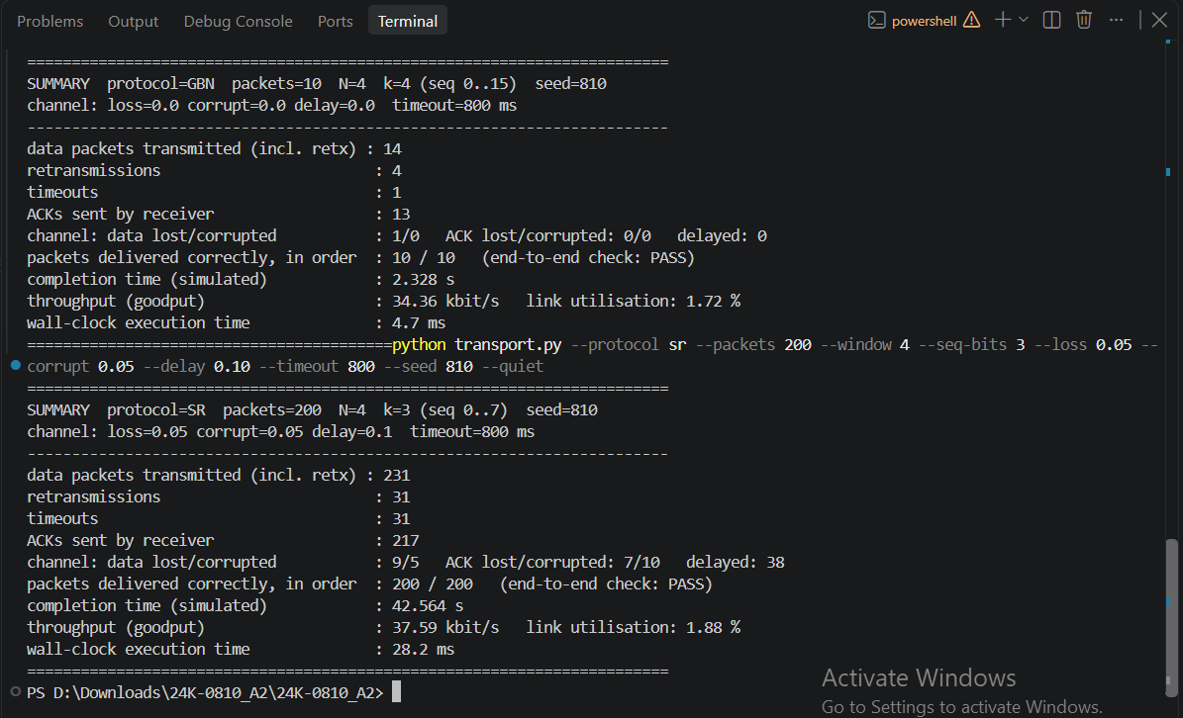
Run: python transport.py --protocol sr --packets 200 --window 4 --seq-bits 3 --loss 0.05 --corrupt 0.05 --delay 0.10 --seed 810. Experiments: 200 packets, N = 4, k = 3, seed 810, timeout 800 ms; loss, corruption and delay apply to packets and ACKs. A = reliable, B = loss 0.10, C = loss 0.05 + corruption 0.05 + delay 0.10 (python experiments.py).
scenario | protocol | seeds | mean_retransmissions | mean_transmitted | mean_time_s | mean_throughput_kbps | all_correct
A: Reliable | GBN | 30 | 0 | 200 | 25.21 | 63.46 | TRUE
A: Reliable | SR | 30 | 0 | 200 | 25.21 | 63.46 | TRUE
B: Loss 0.10 | GBN | 30 | 92.1 | 292.1 | 49.46 | 32.81 | TRUE
B: Loss 0.10 | SR | 30 | 49.5 | 249.5 | 48.92 | 32.95 | TRUE
C: Mixed errors | GBN | 30 | 85.7 | 285.7 | 48.96 | 32.95 | TRUE
C: Mixed errors | SR | 30 | 44.4 | 244.4 | 47.48 | 33.81 | TRUE

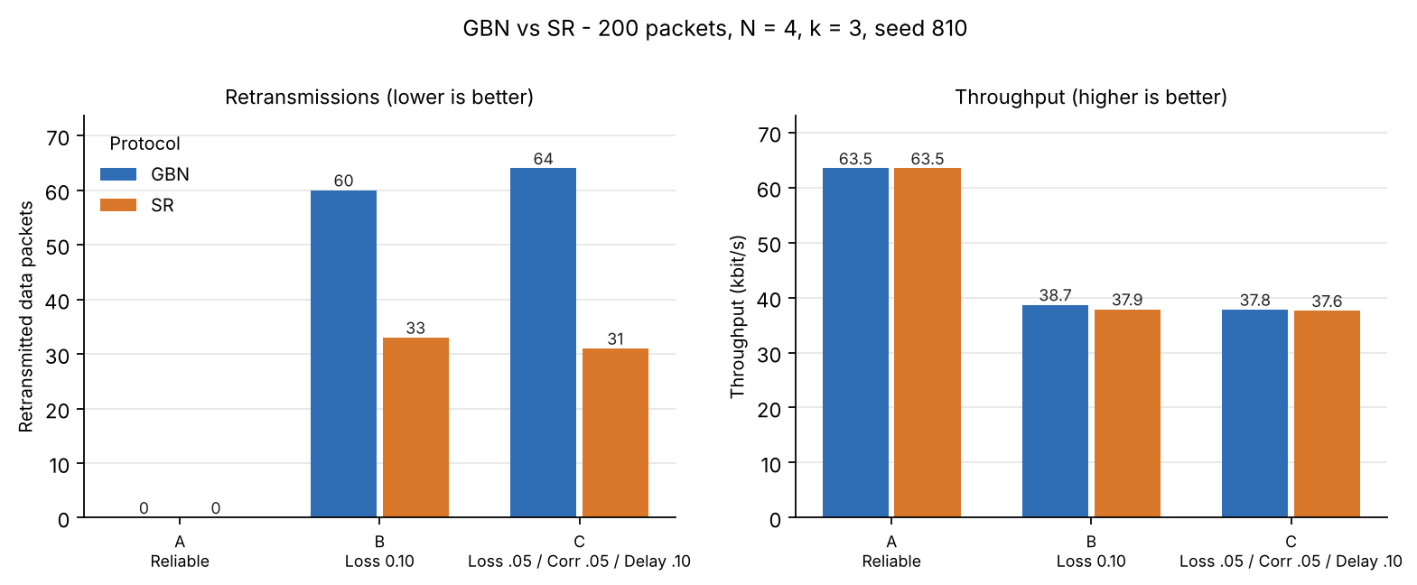
With a reliable channel (A) both protocols behave identically: no retransmissions and all 200 packets delivered in 25.21 s. Under loss (B) and mixed errors (C), GBN retransmits about twice as many packets as SR (60 vs 33 and 64 vs 31). A GBN timeout resends the whole outstanding window, because its receiver discards out-of-order packets. SR resends only the packet whose own timer expired, because its receiver buffers out-of-order packets. Throughput is almost the same because N = 4 is far below the link’s bandwidth-delay product, so both protocols stall for about one timeout per loss. SR’s advantage here is bandwidth saved, not time. Corruption is caught by the checksum and handled like loss, so C looks much like B.
Task 5
1 Pipelining. Explain why pipelining improves link utilization compared with Stop-and-Wait. Support your answer
with U = (L/R) / (RTT + L/R) from the slides, for Stop-and-Wait and for N = 4 on the scenario link.
Stop-and-Wait wastes the whole RTT per packet; pipelining sends N packets per RTT, so utilization grows roughly N-fold until the pipe is full. With L/R = 8000 / 2,000,000 = 0.004 s and RTT = 0.5 s:
Stop-and-Wait: U = (L/R) / (RTT + L/R) = 0.004 / 0.504 = 0.79% (throughput = L / 0.504 s = 15.9 kbit/s).
Pipelined, N = 4: U = N (L/R) / (RTT + L/R) = 4 x 0.004 / 0.504 = 3.17% (63.5 kbit/s) - four times better. N = 126 would be needed to fill the link. The simulator confirms this: run A gives 3.17% utilization and 63.46 kbit/s.
2 Sequence numbers. For SR with 3-bit sequence numbers: (a) how many sequence numbers are available; (b)
What is the maximum safe window size; (c) Why can a larger window cause ambiguity? Support (c) with a small
diagram.
(a)2^3 = 8 sequence numbers (0-7). (b) The maximum safe SR window is 2^(k-1) = 4 (GBN can use up to 2^k - 1 = 7). (c) The sender and receiver windows each span N numbers, and after the receiver slides forward its new window must not contain any number the sender could still retransmit: this needs N + N <= 2^k. With N = 5 the windows overlap on seq 0 and 1 (diagram): if all ACKs of packets 0-4 are lost, the sender resends old packet 0, but the receiver's new window now expects packet 8, which also has seq 0, so it accepts the old copy as new data. I confirmed this in the simulator: SR with N = 5, k = 3, loss 0.2 delivered wrong data in 50 of 50 seeds, while N = 4 was correct in 50 of 50.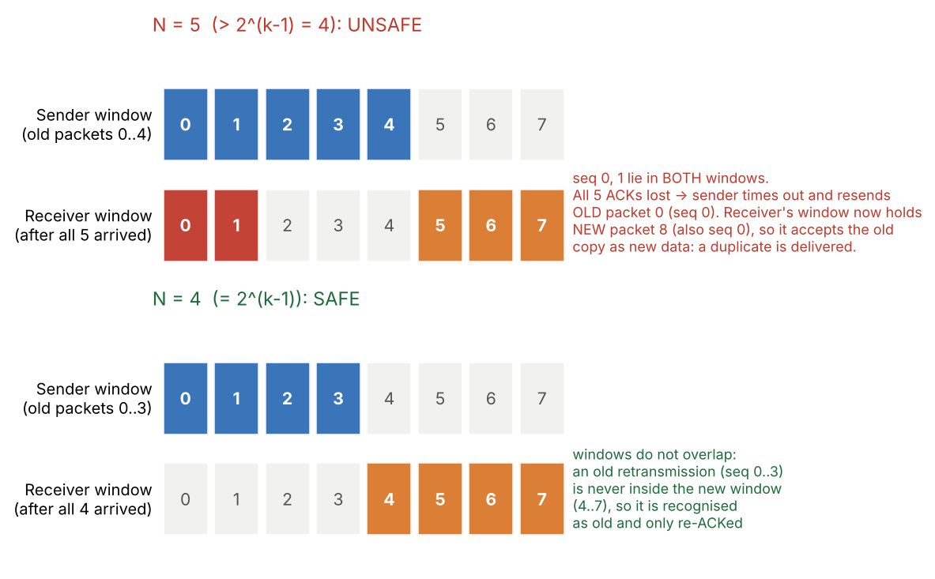
Both protocols deliver every packet correctly and in order over a lossy, corrupting, delaying link; the end-to-end check passed in every run. For this satellite network SR is the better fit: it keeps the same reliability as GBN but retransmits roughly half as many packets under errors, which matters on a bandwidth-limited link, at the cost of receiver buffering, per-packet timers and the window limit N <= 2^(k-1). The biggest remaining inefficiency is not the protocol but the tiny window: with N = 4 only about 3% of the link is used, so a larger window (and more sequence-number bits) would be the first improvement.

